Table of Contents
1. INTRODUCTION TO NONPARAMETRIC METHODS AND SIGN TEST: 2
2. NONPARAMETRIC METHODS, SIGN TEST FOR MEDIAN EXAMPLES 7
3. NONPARAMETRIC METHODS, MANN-WHITNEY-WILCOXON RANK SUM TEST 12
4. NONPARAMETRIC METHODS, MANN-WHYTNEY-WILCOXON SIGNED RANK TEST IN EXCEL 15
5. NONPARAMETRIC METHODS, WILCOXON SIGNED RANK TEST IN EXCEL 19
6. NONPARAMETRIC METHODS KRUSKAL-WALLIS TEST IN EXCEL 23
7. NONPARAMETRIC METHODS, FRIEDMAN TESTI IN EXCEL 28
8. NONPARAMETRIC METHODS, SPEARMAN RANK CORRELATION IN EXCEL 33
9. ARISTONDO'S INSIGHTS: 35

INTRODUCTION TO NONPARAMETRIC METHODS AND SIGN TEST:
What does ``parametric'' mean?
- Nonparametric implies that there is something that is parametric. What is the difference'
- Most statistical methods we are familiar with (such as the confidence intervals, t-tests, ANOVA, linear regression, etc.) make assumptions about probability distributions of the population under analysis (often we need a normal distribution).
- A lot of the assumptions underneath these things we are more familiar with is the assumption that the observations are normally distributed.
- Given these assumptions we can develop sampling distributions. And then from the sampling distributions we can derive sample statistics (mean, standard deviation, etc.).
- Parametric methods are a family of statistical methods that most often make the assumption that the underlying observations are normally distributed.
What does ``Nonparametric'' mean?
- In parametric tests, assumptions are made about the underlying distribution of the population.
- Nonparametric methods DO NOT make these assumptions, nor require these assumptions.
- Sometimes we call these methods ``distribution free'' for this reason, there is NO underlying assumption about the distribution of the data.
- While parametric methods will mostly require quantitative data, nonparametric methods allow us to work with qualitative (nominal/ordinal) data.
  - Nominal:
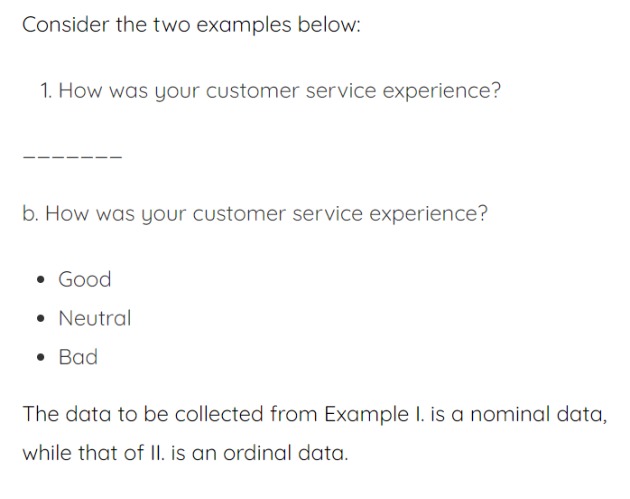 source
  - Ordinal: Ordinal data is a kind of categorical data with a set order or scale to it. A linker scale for categorical ranking is considered to be categorical or a type of ordinal data.
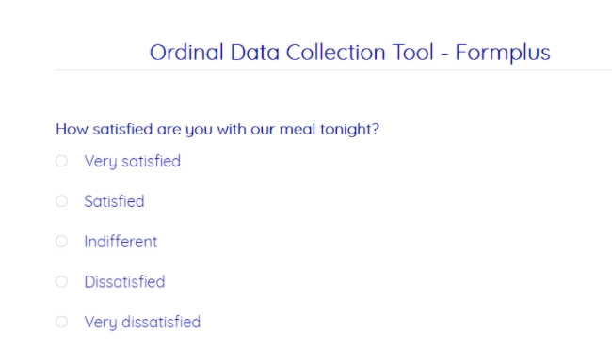 source
- Most of the time, even quantitative data is converted to nominal / ordinal data for use with non-parametric methods; the most common type being ranked observations.
  - Basically you can perform nonparametric methods on ordinal or nominal data, the reason you can do this is that you will always convert the data, regardless of the type, you are not interested in the quantitative characteristics of the data.
Example 1: We have the following data set.
- The median by definition is the $\frac{Quantity of observations}{2}$ , remember the median is a position, an address, it is not part of the data set.
- The median is thus $median=\frac{73,600+78,800}{2}=76,200$.
- Now this can be viewed from a non-parametric way as well.
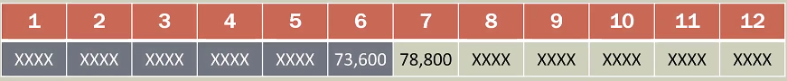
- Notice we are not concerned with the data set, we are just concerned about the number of observations, as we can see the middle (since it’s an even number) is $\frac{73,600+78,800}{2}$ we take the average because the number of observations is even.
- The median by definition means that 50% of the data is below that value, and 50%if the data is above that value. This can be viewed in terms of proportions. As we can see below 76,200, we have 6 and above we have 6.
  - The proportion in this case is that the median has to be $\frac{6}{12}→\frac{1}{2}→ p=0.5$.

Hypothesis testing:
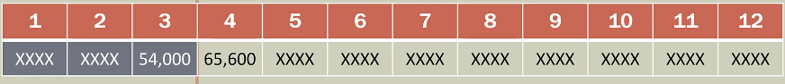
- We can now hypothesize, for example we can say that the median = 60,200. Let's see:
  - We have $\frac{3}{12}→p=0.25$ observations below 60,200.
  - We have $\frac{9}{12}→p=0.75$ observations above 60,200.
  - Now can we say that this is the median? Probably not.
Now let's take the following example, a data set of which we don't know the numbers.
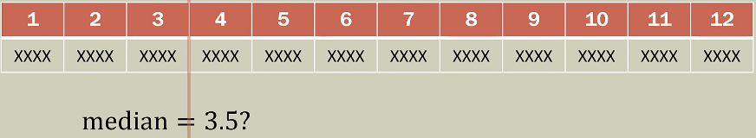
- Saying the median=60,200, landed us in between n=3 & n=4, thus the median would have to be 3.5.
- Hypothesis:
  - $H_{0}:$ median = 0.25
  - $H_{a}:$ median $≠$0.25
- Common sense: the median by definition is half the data is below and half above. Saying the null is 0.25 that should be a red flag, probably if we continue this hypothesis we would most likely reject the null and conclude that the median is not 0.25.
Take this other example:
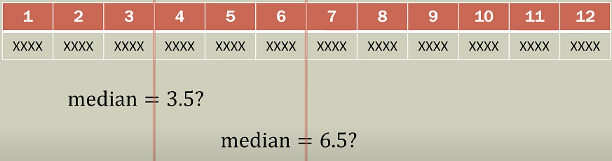
- The median is in this case 6.5 in terms of position.
- Hypothesis:
  - $H_{0}:$median = 0.50
  - $H_{a}:$ median $≠$0.50
- This hypothesis is something we are not going to be able to reject (the null), the reason being that the median in this case is 0.5 by definition.
Take this other example:
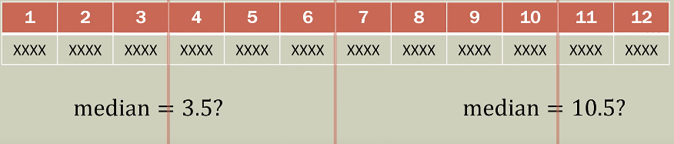
- We say that the median is between 10 and 11, thus in 10.5.
- Notice we have 10 observations in our data set that are below that and merely 2 above.
- Hypothesis: $\left(\frac{10}{12}=0.833\right)$
  - $H_{0}:$ median = 0.833
  - $H_{a}:$ median $≠$ 0.833
- Does it make sense to propose that the median is 0.833? Probably not, and in this case we would be able to reject the null.
- Notice we aren't even looking at the data, we are just hypothesizing based on addresses or locations in the data set.
Sign test:
- Example 1:
  - Parameter of interest: median.
  - Hypothesis:
    - $H_{0}:$median = 60,200 $→p=0.5$
    - $H_{a}:$ median $≠$60,200 $→p≠0.5$
  - Significance: $α=0.05$
  - Analysis:
    - We will put a plus sign for every value that is below the hypothesized median, plus sign for every value that is less than 60,200, minus sign otherwise.
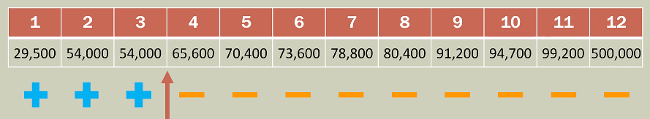
    - We have a total of 3 plus signs. That means we have $\frac{3}{12}=0.25$
    - We can out right conclude we are most likely going to reject the null and conclude the median is not 60,200, because we can see that 0.5 and 0.25 are not similar.
- Example 2:
  - Parameter of interest: median.
  - Hypothesis:
    - $H_{0}:$median = 76,200 $→p=0.5$
    - $H_{a}:$ median $≠$76,200 $→p≠0.5$
  - Significance: $α=0.10$
  - Analysis:
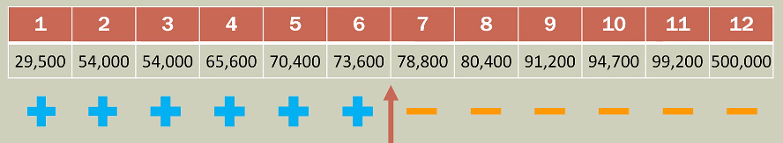
    - We can see we have a total of 6 plus signs, our proportion is $\frac{6}{12}=0.5$, this makes sense since it actually is the median, for this test though we won't be able to reject the null because the null is correct.
- Example 3:
  - Parameter of interest: median.
  - Hypothesis:
    - $H_{0}:$median = 97,600$→p=0.5$
    - $H_{a}:$ median $≠$97,600 $→p≠0.5$
  - Significance: $α=0.10$
  - Analysis:
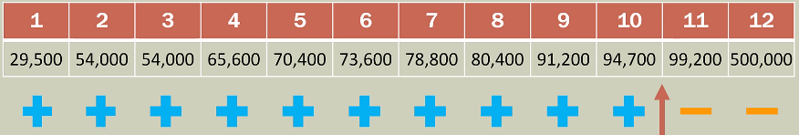
    - We have a total of 10 plus signs which leaves $\frac{10}{12}=0.833$ under that 'median' thus we are most likely going to be able to reject the null and conclude that the median is not 97,600 because 0.833 and 0.5 are not similar.
We are focusing on the position of each value, it isn't really important what the value is, the important part is where it falls relative to the hypothesized median.
Binomial problem:
- What we have is essentially a binomial distribution problem.
- A binomial has two possibilities.
- We turned the quantitative measures (in this case salaries) into two discrete categories: below the hypothesized median (+) and above the hypothesized median (-); the actual values themselves didn’t matter.
- Therefore, we can use the binomial distribution to test our hypothesis about the medium.
- REMOVE ANY OBSERVATION THAT IS EXACTLY EQUAL TO THE HYPOTHESIZED MEDIAN.
Nonparametric:
- As you can see, using the sign test required no assumptions about the distribution of the observations, the only way we used them was for checking if they were greater or smaller than the hypothesized median and discarding them if they were equal.
- We didn't make any assumptions like checking if the data was normally distributed or uniformly distributed or whatever else.
STEPS FOR THE SIGN TEST:
- Hypothesize about the median.
- Rank order the data visually (optional sorting).
- Remove all values that are exactly equal to the hypothesized median.
- See which observations fall below or above the hypothesized median.
- Use the binomial distribution to test our hypothesis.
REMEMBER: THE MEDIAN IS A MEASURE OF LOCATION, AN ADDRESS, THE VALUES DON'T MATTER, non-parametric means we do not care for the distribution our data follows, nor the values, we just use them to determine the location.

SIGN TEST FOR MEDIAN EXAMPLES
- Using the binomial distribution.
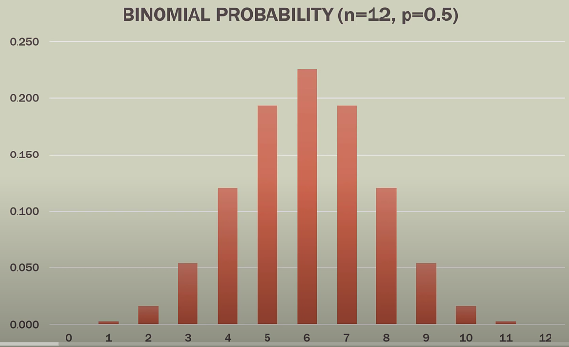
  - n=12 because of the quantity of observations.
  - p=0.5 because we have a 50% chance of either getting a success or failure.
  - Consider you have thousands of people in an arena and they each have a coin, you ask them to flip them 12 times and send the results, the figure above is most likely what those results would look like.
  - Galton Board
  - Think of the sign test in this way, in the median we would expect 6 plus signs and 6 negative signs.

Example median = 60,200:
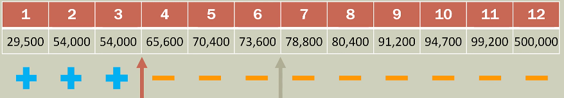
- Data:
  - n = 12
- Hypothesis:
  - $H_{0}:$ median = 60,200 $→p=0.5$
  - $H_{a}:$ median $≠$ 60,200 $→p≠0.5$
- "Plus" signs below the median: $3→\frac{3}{12}=0.25$, is this similar to 0.5?
- Calculate statistic:
  - Use: =BINOM.DIST(number in question, number of observations, probability of either outcomes (+,-), FALSE)
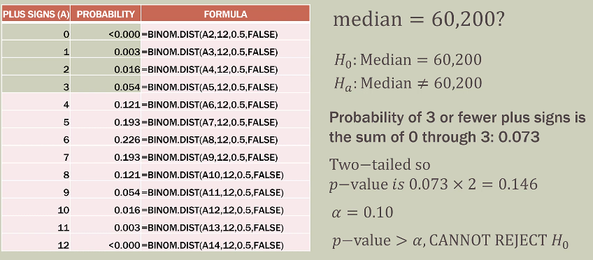
- This is a small sample size. For larger sample sizes we approximate to the normal distribution.
Example median = 76,200 (this is the actual median):
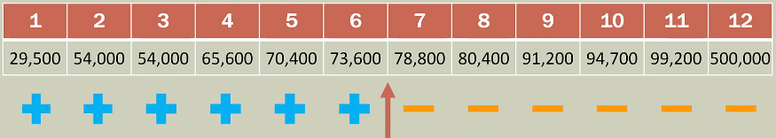
- Data:
  - n = 12
- Hypothesis:
  - $H_{0}:$ median = 76,200 $→p=0.5$
  - $H_{a}:$ median $≠$ 76,200$→p≠0.5$
- "Plus" signs below the median: $6→\frac{6}{12}=0.5$, is this similar to 0.5? Yes.
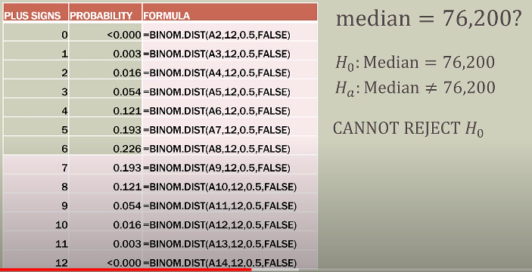
Example median = 96,700: 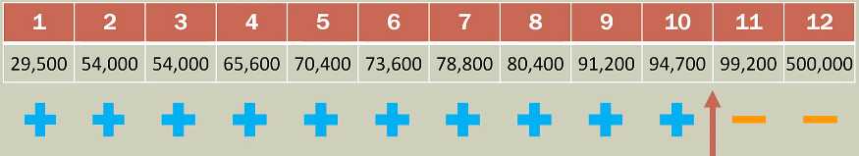
- Data:
  - n = 12
- Hypothesis:
  - $H_{0}:$ median = 96,700 $→p=0.5$
  - $H_{a}:$ median $≠$ 96,700$→p≠0.5$
- "Plus" signs below the median: $10→\frac{10}{12}=0.833$, is this similar to 0.5? Probably not.
In a strict parametric sense, we are saying by these examples:
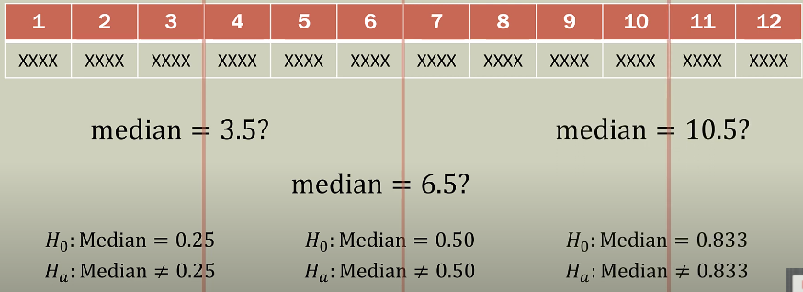
Calculate statistic:
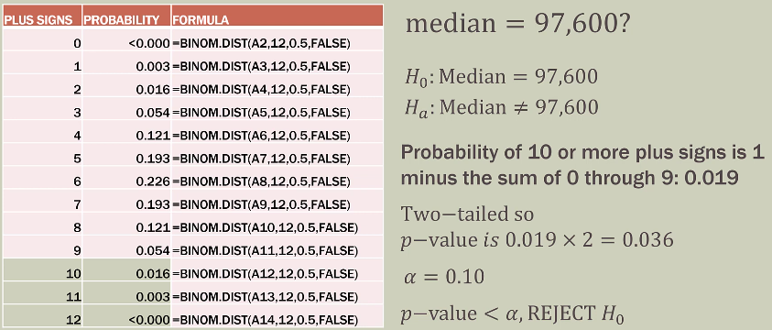
Sample size greater than 20: If were using the sign test and n $≥$ 20 we can use the normal approximation to keep us from adding up probabilities.
- If the sample size is greater than 20, we can use the normal approximation of the binomial distribution.
- If the sample size is $n≥20$ [hay que ver por que Aristondo cambia las cosas ] the two distributions converge, and they are basically the same.
- Formulas:
  - $H_{0}:p=0.5$
  - Mean: $μ=0.5×n$
  - Standard deviation: $σ=\sqrt{0.25×n}$
Example Larger Salary Sample:
- HR ways the median salary for your company is at least $75K. However, a sample of 86 salaries found that 34 of those salaries were greater than $75,000. One salary was exactly $75,000 so for the sign test it was discarded and therefore 85 salaries were used. Consequently, 51 (85,34) salaries were less than $75,000.
- In this problem we will conduct a one tailed test and use the normal approximation to the binomial distribution. "At least" means one tail, we expect the salaries to be at least 75,000 thus that is what we put in the null.
- Hypothesis:
  - $H_{0}:$median $≥$ 75,000
  - $H_{a}:$median $<$ 75,000

  - The question were trying to solve in this problem is: is the difference significant enough to reject the null?
- Calculating statistic:
  - $H_{0}:p=0.5$
  - Mean: $μ=0.50×n→0.50×85=42.5$
  - Standard deviation: $\sqrt{0.25×n}→\sqrt{0.25×\left(85\right)}=4.61$
  - p-value = $P(x≤34.5)$
    - What is the probability that the number of salaries that are greater than $75,000 is 34 or less.
    - Continuity correction factor:
      - Less than or equal to $(≤)$: ADD 0.5
      - greater than or equal to $(≥)$: SUBTRACT 0.5
  - Now use a z-value:
    - $P=\left(z≤\frac{x-μ}{σ}\right)=\left(z≤\frac{34.5-42.5}{4.61}\right)=\left(z≤-1.735\right)=0.0413$
    - Use a tool to calculate this.
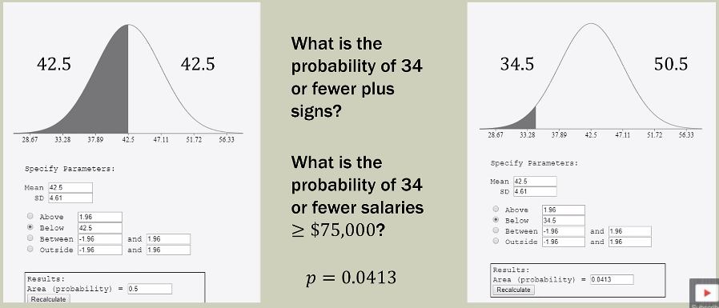
    - p-value = 0.0413
    - $α=0.05$
    - Reject if p-value $≤$ 0.05
      - 0.0413$≤$ 0.05: True.
    - Reject the null.
- Conclusion:
  - It is very unlikely that there would be 34 or less values above the hypothesized median, the median salary is less than 75,000.
  - Therefore, we can reject the null and conclude that the median salary is actually less than 75,000.
  - Always use common sense to go back and check the conclusion. In this case, 51 of the 85 salaries were less than $75,000 so the rejection of $H_{0}$ makes sense.

Quick review:
- The sign test is a nonparametric method for testing a hypothesis about the median of a dataset.
- We convert each value to a plus or minus sign depending on if it falls below or above the hypothesized median, respectively.
- We then count the plus signs and implement the binomial distribution.
- If an observation(s) is the same as the hypothesized value, those observation are removed, and the test continues with a smaller sample size.
- If the sample size is larger than 20, the normal approximation to the binomial distribution can be used.

MANN-WHITNEY-WILCOXON RANK SUM TEST
- Conceptual background of this test. Previously we looked at the medians of one sample, the MWW test allows us to look at the median of two samples.
Notes:
- The Wilcoxon Rank Sum test and the Mann-Whitney test achieve the same result and are essentially the same test.
- They do however have slightly different test statistics.
- Sometimes you will see it as Mann-Whitney-Wilcoxon test, some text books and other resources they combine the name into one (others just refer to it as the Mann-Whitney test).
- Both are testing for the location of or comparing two medians.
- Can be used with quantitative data or ordinal data, in the end we are actually going to turn everything into ordinal data anyway.
- If you are looking for one test in software, and can't find it, it might be listed as the other one (Mann-Whitney test, remember the MW test and the Wilcoxon rank test achieve the same result, some software lists the combined).
- Each test also has its own subscripts, so don't get confused.
Background:
- If we were doing a parametric version of this test, comparing two samples using parametric test would lead us to use an independent samples t-test (comparing the location of two means and both samples were assumed to have normal distributions).
- This is the non-parametric version of the independent samples t-test.
- In that case we would test (most of the time) if the means of the two samples are equal: ${\overline{x}}_{1}-{\overline{x}}_{2}=0$ (means are equal).
- The assumption in parametric testing is that each population is normally distributed.
- The Wilcoxon Rank Sum or Mann-Whitney test allow us to compare two populations where the underlying distributions are not normal but do have similar shape.
- To do this we use the ranks (or locations) of the observations, not the values.
General Hypothesis:
- $H_{0}:$The two populations are the same.
- $H_{a}:$ The two populations are not the same.
- Rejecting the null hypothesis means one population tends to have either smaller or larger values than the other (remember they have the same shape).
- One tailed tests are also possible of a certain direction of the difference is hypothesized, this means we can say the following (were talking about both the MW test and the WR sum test):
  - The two medians are in the same location, or equal.
  - One median is above another.
  - One median is below another
Population visuals:

- Notice there is not much overlap between these two populations and the medians are pretty far apart.
- Here we would most likely reject the null hypothesis that the median of both populations are the same.

- Here the medians are closer together.
- Here we may or might not.

- Here the two medians are very very close.
- Most likely here we might not reject the null hypothesis that they are the same because they are very close.

Example Mumbai Starbucks:
- Ten students from Mumbai, India who often study at Starbucks were asked to provide ratings for two stores.
- Five students were asked to review the Churchgate store (C).
- A different set of five students were asked to review the Nariman Point store (N).
- The survey covered five criteria: Cleanliness, Service, Facilities, Drink Quality, and Food Quality each on a scale of 1 to 5.
- The lowest score possible is 5 and the maximum is 25.
- The score itself is not really important were locking for the ranks.
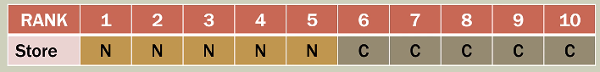
- Now we sum the ranks for each store.
  - 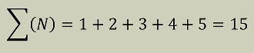
  - 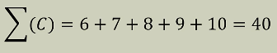
- Therefore, the sampling distribution for the sum of the ranks is between 15 and 40 (inclusive).
- IMPORTANT: If the populations for each one of these stores is the same (in terms of their scores and the ranks), we would expect the sum of the ranks to be near the middle: (15+40)/2=27.5.
- The population looks like this:

- Since they all ranks of N are in the left and all ranks of C are in the right. They don't even overlap.
SUM OF RANKS (MIXED):
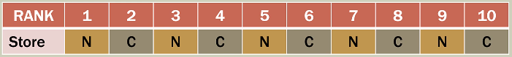
- Sum of the ranks:
  - 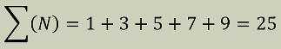
  - 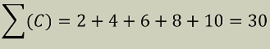
  - Remember it the medians are actually close we would expect the sum of N and C to be close to 27.5.
  - IMPORTANT: If the populations are the same, we expect the sum of the ranks to be near the middle: (15+40)2=27.5.
  - In this situation they are pretty close to the average of the ranks.

  - Here we would most likely fail to reject the null because they are so close, we can say they are basically the same population.
Hypothesis formulation:
- In the Wilcoxon Ranked Sum or the Mann-Whitney-Test we can do any of these situations.
- We can have Two tailed tests:
  - $H_{0} :{\tilde{μ}}_{1}-{\tilde{μ}}_{2}=0$
  - $H_{a} :{\tilde{μ}}_{1}-{\tilde{μ}}_{2}≠0$
- Also, a lower-tail test:
  - $H_{0}: {\tilde{μ}}_{1}-{\tilde{μ}}_{2}≥0$
  - $H_{a}: {\tilde{μ}}_{1}-{\tilde{μ}}_{2}<0$
  - TIP: the alternative hypothesis points in the direction of you test. Lower tailed tests are denoted by < because its pointing to the left and upper tailed tests are denoted by > because its pointing to the right.
- Also, upper-tail test:
  - $H_{0}:{\tilde{μ}}_{1}-{\tilde{μ}}_{2}≤0$
  - $H_{a}:{\tilde{μ}}_{1}-{\tilde{μ}}_{2}>0$

MANN-WHITNEY-WILCOXON SIGNED RANK TEST IN EXCEL
Example:
- Professor Tyson is on thin ice with the academic department. Student evaluations for the course have not been up to the standards of the university.
- Professor Tyson is put on notice that student evaluations must improve next semester (Spring). Since student evaluations are ratings (1 to 10) (linker scale), it is determined that a rank sum test will be to see if there is a statistically significant difference in course evaluations from Fall to Spring semesters.
- This is a very common usage for the MW or WRS tests since we have something that does not necessarily follow a normal distribution. A nonparametric test is a better way of approaching this data. We will see if Professor Tyson improved or got worse in the spring semester.
Step by step:
- Place samples into two columns.
- In a third column, stack the two samples into one column.
- In a fourth column, rank each value in the stacked column.
- For any tied ranks, use the average rank; in Excel use the function =RANK.AVG. ranks(1,2,3,4) [second and third numbers are the same] = (1,2.5,2.5,4).
- Sum the ranks for each sample.
- Use the sampling distribution and test statistic to find the p-value.
- Compare p-value to chosen alpha level.
Setting up the professor Tyson test:
- Here you can use a two tailed test, upper or lower. We want to see if there is improvement.
- Hypothesis:
  - $Semester_{1}$: fall (the first semester).
  - $Semester_{2}:$ spring (the second, the one were Professor is supposed to improve).
  - $H_{0}:Median_{1}-Median_{2}≥0$; this means the median of the fall semester is greater than the median of the spring semester, he is the same or even got worse.
  - $H_{a}:Median_{1}-Median_{2}<0$; this means the median of the spring semester (the semester he was supposed to improve) is greater than the first semester, thus he improved.
- Our assumption (null hypothesis) is that the ratings have not changed between semesters. Or that they went down. The rejection of that assumption (alternative hypothesis) would mean that $semester_{1}$ is less than $semester_{2}$.
- If the null is rejected (the difference is negative) then Professor Tyson will not be fired.
Sampling distribution:
- We need a few things in order to conduct this investigation. First the mean.
- Mean:
$$μ_{w}=\frac{n_{1}(n_{1}+n_{2}+1)}{2}$$
- Standard deviation:
$$σ_{w}=\sqrt{\frac{n_{1}n_{2}\left(n_{1}+n_{2}+1\right)}{12}}$$
- The sample sizes can be different but are usually equal.
- We can use a normal approximation for $n≥10$ (some books have it differently, some say 7 and others say 10, stick to whatever your professor tells you).
- The subscripts for these formulas can be different in books, other books have it as $μ_{T}$ or $σ_{T}$.
Test statistic:
- The z score is a measure of how many standard deviations our observation is or observed mean is below or above our expected mean, it's just a measure of distance in terms of standard deviations.
$$z=\frac{W-μ_{w}}{σ_{w}}$$
- The test can also be two-tailed or one-tailed depending on your research question.
Excel:
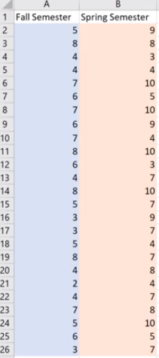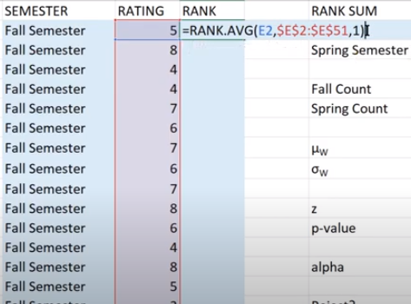
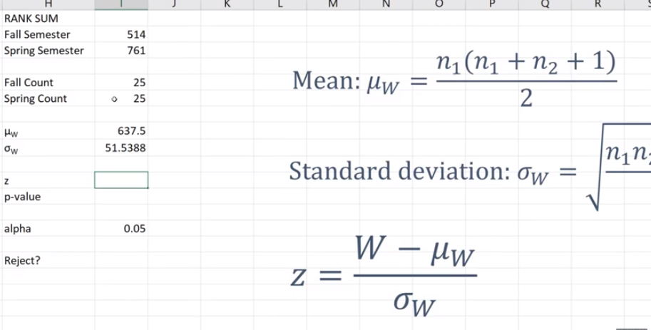
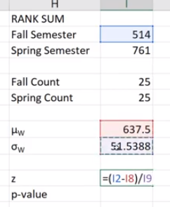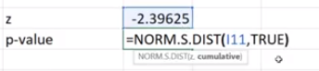
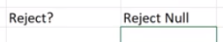
- In conclusion, Professor Tyson improved his ratings in a way that is statistically significant.
Sampling distribution (same example viewed algebraically):
- 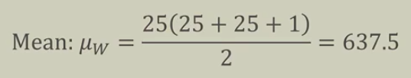
- 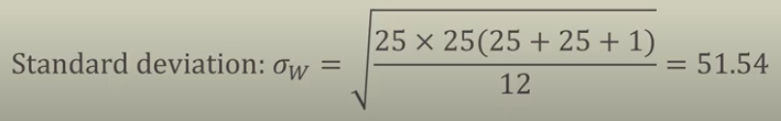
- 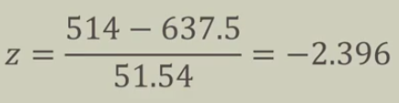
  - TRUE is for cumulative because we want the area between $-∞$ to -2.396.

WILCOXON SIGNED RANK TEST IN EXCEL
- It is a combination of the signed test and the MW.
- This is a paired test. Paired wise test where we look for differences.
Background:
- Comparing two matched samples using a parametric test would lead us to use a matched sample t-test; (before/after), (pre/post).
- In that case we would test (most of the time) if the mean difference between the matched pairs is zero, $\overline{d}=0$.
- For example: measure performance of employees between two methods.
- The assumption however for parametric is that each population is normally distributed.
- Wilcoxon Signed-Rank test allows us to compare two populations that violate the assumption of normality.
- The only requirement is that the distribution of differences is symmetrical (median), not necessarily normally distributed.
- This is the non-parametric version of the matched sample t-test, we won't be using data value we would be using the ranks.
YouTube A/B Testing:
- Chloe is an up and coming YouTube creator from Perth, Australia. She is looking to increase engagement on her channel by improving click though rate (CTR). A common method to increase CTR is by using quality video thumbnails.
- Using a third-party tool, Chloe performs a 72-hour A/B test on 25 videos using two thumbnail styles; selfie photo and with no selfie photo. The tool alternates A/B. Chloe then downloads the data on how many clicks each thumbnail received per video.
- We want to see which one is clicked most often, the selfie or the no-selfie one, or if there is any difference?
- The data:
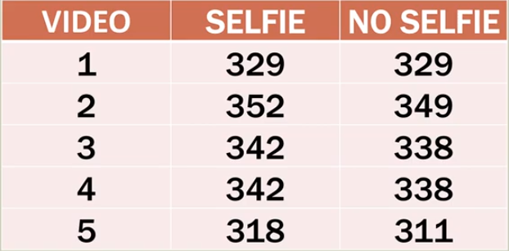
  - Consider that video one for instance has the same content, it merely is changed only the thumbnail.
Step by step: WILCOXON SIGNED RANK TEST.
- Place matched samples into columns.
- In a third column, subtract column 2 from column 1 to obtain differences.
- In a fourth column, take the absolute value of each difference in column 3 (this is called the absolute difference).
- If there are any differences that result in zero, those will be discarded for this test.
- Rank the absolute differences from smallest to largest; any tied ranks are averaged. Use the =RANK.AVG function in excel.
- Record any ranks from negative differences as negative ranks in column 4.
- Record any ranks from positive differences in column 5.
- Add up the positive signed ranks, known as $T^{+}$.
- Calculate mean and standard deviation.
- Calculate z statistic and find its p-value.
Sampling distribution:
- Mean:
$$μ_{T^{+}}=\frac{n\left(n+1\right)}{4}$$
- Standard deviation:
$$σ_{T^{+}}=\sqrt{\frac{n\left(n+1\right)\left(2n+1\right)}{24}}$$
- n is the sample size and any differences of zero are removed.
- Normal approximation for $n≥20$.
  - Remember, nonparametric statistics are always discrete, they are not continuous, however sometimes they can be approximated to a continuous distribution if the samples are large enough.
Test statistics and probability:
- What is $μ_{T^{+}}$?
  - This is the mean of our sampling distribution if the positive and the negative in the ranks were evenly balanced.
- The question is: is $T^{+}$ in the upper tail or lower tail of the sampling distribution relative to $μ_{T^{+}}$?
  - Is $T^{+}$above $μ_{T^{+}}$ or below.
- If $T^{+}$ test statistic is in the upper tail, this is how we find the probability:
$$P\left(z≥\frac{T^{+}-μ_{T^{+}}}{σ_{T^{+}}}\right)$$
  - This is just a z score.
- If $T^{+}$ test statistic is in the lower tail, this is how we find the probability:
$$P\left(z≤\frac{T^{+}-μ_{T^{+}}}{σ_{T^{+}}}\right)$$
- If $T^{+}$ test statistic is a two-tailed test: multiply by two the probability.
- Continuity factor to $T^{+}$, some textbooks don’t add it, some software don’t add it, others add it by default.
  - $≤:$ $T^{+}+0.5$
  - $≥:$ $T^{+}-0.5$
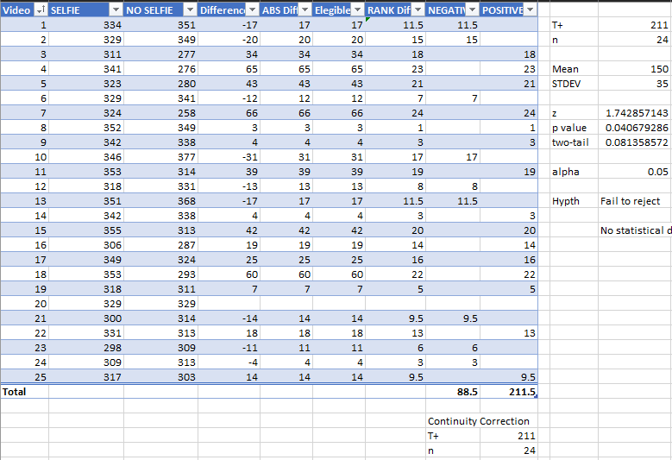
Sampling distribution result:
- 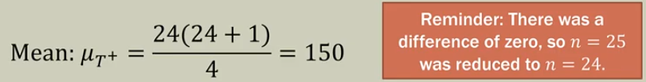
- 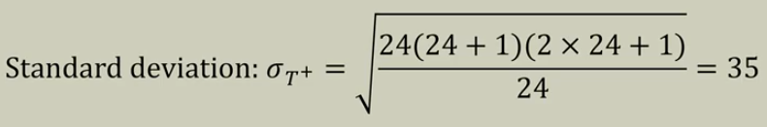
- 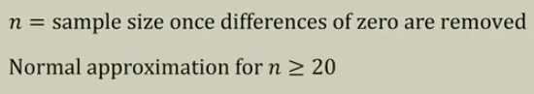
Test statistic, Hypothesis result:
- 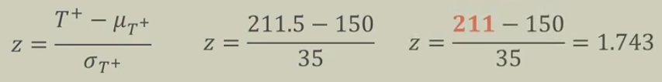
  - We apply the continuity correction factor.
  - Here are some visuals:
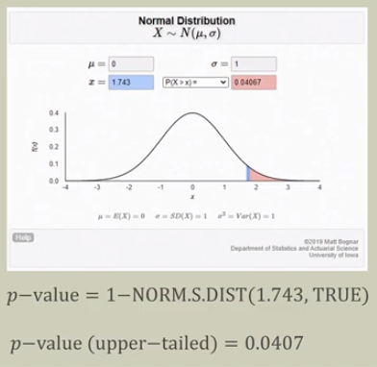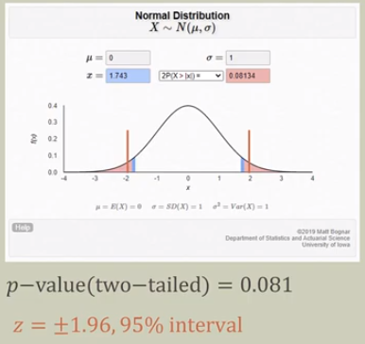
- 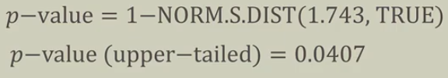
  - We want the right tail, so we subtract from one to get the slice to the right.

KRUSKAL-WALLIS TEST IN EXCEL
- The Kruskal-Wallis test is basically the nonparametric version of one-way-ANOVA test.
Background:
- Comparing more than two independent samples using a parametric test would lead us to use the ANOVE procedure.
- In that case (ANOVA) we would test (most of the time) if the means of the samples are equal: ${\overline{x}}_{1}={\overline{x}}_{2}={\overline{x}}_{3}=…={\overline{x}}_{k}$.
- However, the assumption for ANOVA is that each population is normally distributed.
- The Kruskal-Wallis test allows us to compare more than two populations that violate the assumption of normality.
- We use the sum of ranks for observations, in other words, the locations relative to each other.
Population visuals:

- Here we have three populations, they barely are overlapping, here the most likely case is that will conclude that these three populations are not equal.

- Here population 1 & 2 are closer and overlap more, in this case we would conclude that these three populations are not the same, even though population 1 & 2 are very close to each other the test is asking whether all three are the same.

- Here all populations are pretty close together, the overlap, here we would most likely conclude that the populations are statically the same, consider when we say "same" means that there is no statistically considerable difference between them the are not identical though.
Mumbai Starbucks:
- Forty-five (45) randomly selected coffee lovers from Mumbai, India who often study at Starbucks were asked to provide ratings for three stores; 15 ratings per store.
- The reviews were for the Churchgate (C), Nariman Point (N), and Taj Mahal Palace (T) stores.
- The survey covered five criteria: cleanliness (1-5), service (1-5), facilities (1-5), drink quality (1-5), and food (1-5), each on a scale of 1 to 5.
- The lowest score possible is 5 and the maximum 25.
- However, the score is not important, it is the rank that is important.
Sum of ranks (extreme, no ties):
- This means the Nariman Point store, when we put all of our observations in a rank, that it had the first 15 ranks all to itself.
- Here, the Churchgate store had all the middle ranks to itself.
- Finally, the Taj Mahal Store had the final ranks all to itself.
Consider:
- You can see here we have all 45 observations, there are no ties.
- Now sum all the ranks corresponding to each rank.
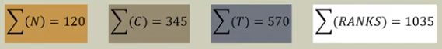
- Visually it would look like this:
Sum of ranks (alternating, no ties):
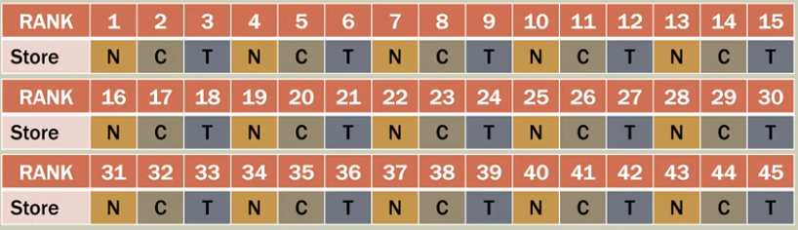
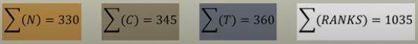
- Consider that the middle is 345, if we were to grab the total ranks and divide by three (average) we would get 354. $\frac{1035}{3}=345$.

- Visually it looks like this.
General Hypothesis:
- $H_{0}:$ All populations are the same.
- $H_{a}:$All populations are not the same.
- Rejecting the null hypothesis means that there is a difference among the locations of the populations. (But it does not tell us where).
- All Kruskal-Wallis tests are one-tailed tests because it uses the chi-square distribution to obtain the p-value.
  - The chi-square tests what we observe vs what we expect, in the null hypothesis where all populations are the same we would expect the sum of the ranks for each of our three populations to be $\frac{1035}{3}=345$.
  - We are testing if the sum of our ranks is 345 for (N), 345 for (C), 345 for (T).
  - Chi-squared test is appropriate because we are using the ranks, we are not using the ratings but rather the ranks that the stores were given.
Sampling distribution:
- The Kruskal-Wallis is denoted by the letter H.
- Formula for the Kruskal-Wallis test statistic:
$$H=\left[\frac{12}{n_{T}\left(n_{T}+1\right)}\sum_{i=1}^{k}{\frac{R_{i}^{2}}{n_{i}}}\right]-3(n_{T}+1)$$
  - $k:$ number of populations.
  - $n_{i}:$ the number of observations in sample $i$.
  - $n_{T}=\sum_{i=1}^{k }{{(n}_{i})}:$the total number of observations in all samples. In this case 45.
  - $R_{i}:$ the sum of the ranks for sample $i$.
Test statistic and p-value:
- Test statistic: $H>χ_{α, \left(k-1\right)}^{2}$.
  - Chi-square of the determined alpha level and degrees of freedom equal to $k-1$.
- What we are asking is: is the sum of the ranks for each group the same?
  - 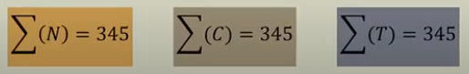
- The p-value is the probability that chi-squared is greater H:
$$p-value: P(χ^{2}>H)$$
Step by step KRUSKAL-WALLIS:
- Place samples into $k$ columns.
- In a new column, stack the $k$ samples into one column.
- In a fourth column, RANK each value in the stacked column.
- For any tied ranks, use the average rank; in excel use the =RANK.AVG ascending.
- Sum the ranks for each sample, pivot table.
- Calculate the Kruskal-Wallis, $H.$
- Compare the p-value to the chosen alpha level using the chi-square distribution.
Excel:
- 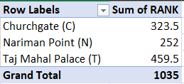
  - As you can see right from here, the ranks are not very similar to 345.
- 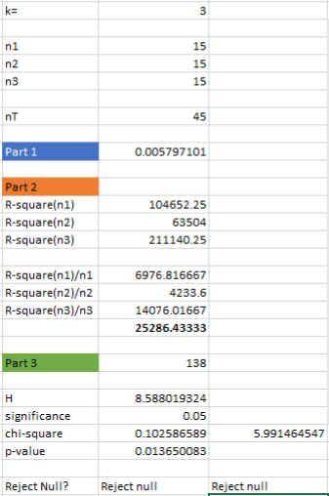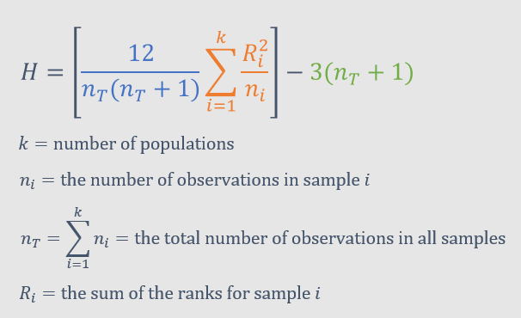
  - The process was done in three parts.
Test statistic and p-value:
- Test statistic: $H>χ_{crit}^{2}→8.58>5.99$; reject the null.
- $p-value:P(0.014)$
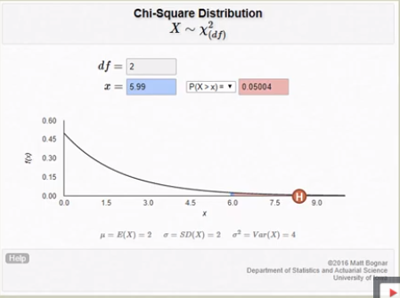
  - To reject the null the p-value has to be smaller than the significance or the critical value of chi-squared has to be greater than H.

FRIEDMAN TESTI IN EXCEL
Background:
- Comparing more than two independent samples with a blocking variable using a parametric test would lead us to use the two-way block ANOVA procedure (no replication).
- In that case we would test if the means of the samples are equal: ${\overline{x}}_{1}={\overline{x}}_{2}={\overline{x}}_{3}…={\overline{x}}_{k}$ while accounting for variation in the blocking variable (the blocking variable siphons away error so we can focus on the error of the model or SE).
- The nonparametric version of the two-way block ANOVA is the Friedman test (very similar to the Kruskal-Wallis test).
- The Friedman test allows us to compare more than two populations with a blocking variable without having to assume the observations are normally distributed.
- Therefore, we use the ranks of the observations (or the locations of the observations in the data set not the actual values themselves).
Mumbai Starbucks:
- Fifteen students from Mumbai, India who often study at Starbucks were asked to provide ratings for four stores; each store (treatment) is being rated by each student (block).
- Each student was asked to review the Churchgate (C), Nariman (N), Taj Mahal Palace (T), and Horniman Circle (H) stores (four stores in the same general area).
- The survey covered five criteria: cleanliness, service, facilities, drink quality, and food quality each on a scale of 1 to 5.
- The lowest score possible is 5 and the maximum is 25 (per student).
- However, the score is not important, it is the RANK that is!
- Is there a difference between the stores taking the raters into account?
General Hypothesis:
- $H_{0}:$All treatments are the same.
- $H_{a}:$ All treatments are not the same.
- Rejecting the null means that there is a difference among the blocked treatments. It does not tell us where that difference is among the treatments (That would require some sort of post hoc analysis which the instructor will get at the end of the playlist).
- All Friedman tests are one-tailed tests because it uses the chi-squared distribution to obtain a p-value.
Treatment (Store) visuals:

- This is how the treatments would look like if they are not identical. Each is very far apart. Here we would most likely reject the null hypothesis because there probably is a statistical difference between the treatments.

- Do treatment 1,2,4 almost equal and treatment 3 is separated? Here we most likely would also reject the null hypothesis, even though the treatments 1,2,4 are almost statistically identical the null is asking if all are identical.
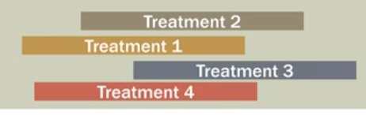
- Here we would probably fail to reject the null, the reason being is that there is likely no statistical difference between all treatments.
Step by step:
- Place blocks into the first column.
- Place treatments into $k$ columns (the four stores in the case of the example).
- In $k$ additional columns, RANK the $k$ treatments across blocks.
- For anu tied ranks, use the average rank; in excel use the function =RANK.AVG ascending.
- Sum the ranks for each treatment at the bottom of the columns.
- Calculate the Friedman statistic, $F_{r}$(you can also see it as $F_{t}$ some books have it differently).
- Compare the p-value to chosen alpha level using the chi-squared distribution.
Sum of ranks (extreme):
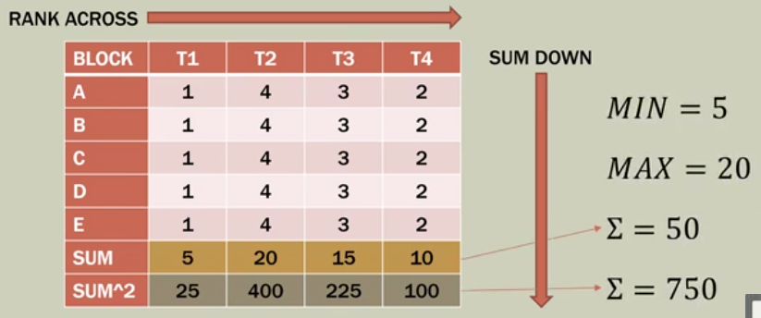
- Rank across (from left to right), then sum down.
- Here we would most likely reject the null hypothesis since the treatments are not very equal.
Sum of ranks (mixed):
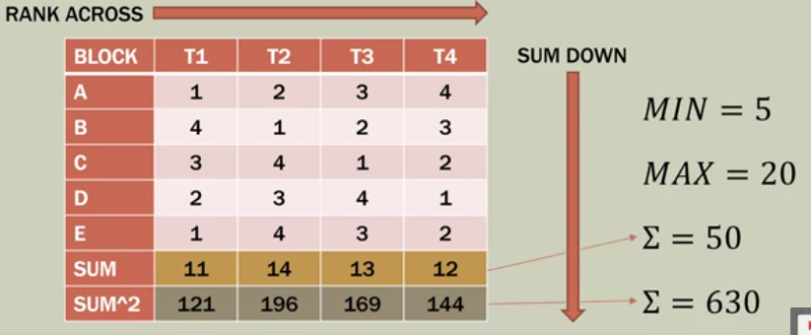
- Here we would most likely fail to reject the null hypothesis.
Sum of ranks (expected, $H_{0}$):
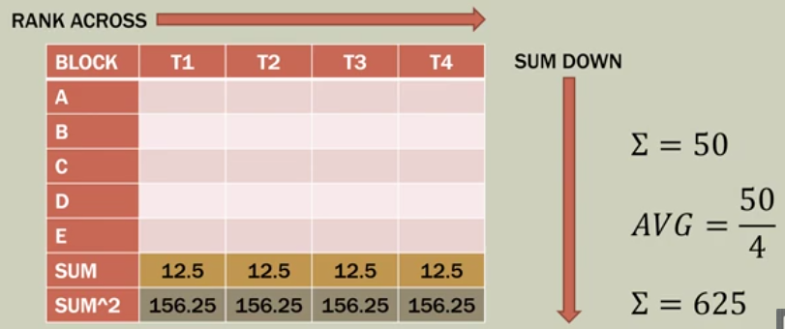
- Fundamentally what we are asking through the null hypothesis is: are the treatments equal, or is there a statistical difference between them? Here theoretically we can assess if the sum of the treatments are similar to 12.5.
- Whenever we want to test actual vs expected we use the chi-squared. We are going to test this (when the treatments are equal) to what we actually observe in our data and then conclude if the hypothesis is true, basically you are comparing your data to the ideal case and testing for equality.
Sampling distribution:
- The Friedman statistic or $F_{r}$ is calculated as follows:
$$F_{r}=\left[\frac{12}{b\left(k\right)\left(k+1\right)}\sum_{j=1}^{k}{T_{j}^{2}}\right]-3b\left(k+1\right)$$
  - $k:$ number of columns (treatments).
  - $b:$ number of rows (blocks).
  - $T_{j}^{2}:$ the squared sum of the ranks for sample treatment (column) $j.$
Test statistic and p-value:
- For the test we ask this: if the test statistic ($F_{r}>χ_{a, k-1}^{2}$)(the Friedman statistic is greater on the left than on the right) then reject the null
- You can also use the p-value to significance criteria: $p-value:P\left(χ^{2}>F_{r}\right)<α$ then reject the null.
Excel:
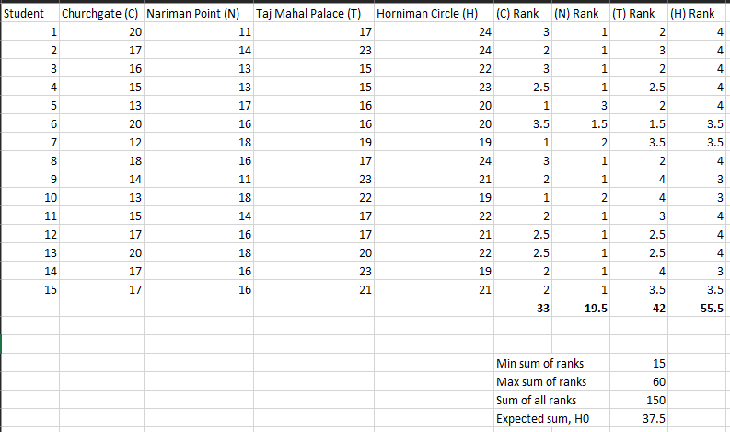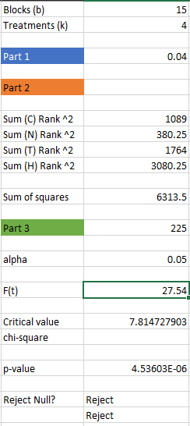
Test statistic and p-value:
- Test statistic: $F_{r}>F_{crit}→27.54>7.815.$ Reject.
- p-value: $P(<0.001)$. Reject.
- Visually it looks like this:
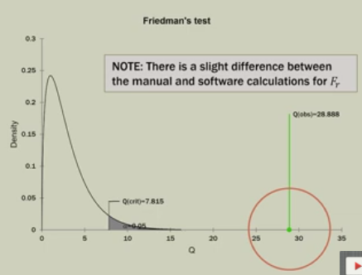
- We would reject the null, see how the $F_{crit}$ is way less than $F_{r}$.

SPEARMAN RANK CORRELATION IN EXCEL
Correlations:
- There are two types of correlations, the Pearson correlation and the Spearman correlation.
Dow 30 stock daily ranks:
- One way to analyze the daily change in a stock's value is the daily percentage change; day-over-day change as a percentage. While percentage change is quantitative, working with percentages can get tricky. (Day over day change as a percentage).
- If we use a stable fixed list* of stocks like the Dow Jones 30, we can rank each stock in the list by its percentage change day to day. Then we can use Spearman Rank-Correlation to see if there are any patterns about the best/worst performing stocks. (Dow Jones 30 is 30 stocks tracked day by day).
- Normally we would do the Pearson product correlation but if we don't have the data normally distributed we would use the Spearman Rank Correlation, if we do the Pearson Correlation on the ranks we get the same values.
- The question is this: Do the stocks tend to be in the same order (rank) by percentage change from day to day?
Spearman Rank-Correlation:
- The Pearson product moment correlation is what we are most familiar with and learn at the beginning of statistics, $r$.
- Person correlation coefficient is for quantitative data.
- When the data is ordinal or rank-ordered we use the Spearmen Rank-Correlation coefficient, $r_{s}$ (notation for this might change depending on the resource).
- If you run a Pearson correlation on the ranks (not the original quantitative data), you will get the same result as the Spearman; Pearson (ranks) = Spearman.
- The observation must be present in BOTH measures (called bivariate), otherwise ranks cannot be compared (because there are not two measures for the stocks).
General Hypothesis:
- $H_{0}:ρ=0 → H_{a}:ρ≠0$
- If our p-value is lower than our chosen significance level, then we would reject the null hypothesis, $H_{o}.$
- There would be evidence to suggest that the rank-correlation is not zero (for this there is .
Generic correlations of ranks:
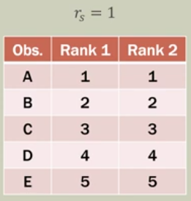
- This is a 'perfect' Spearman rank correlation coefficient of 1.
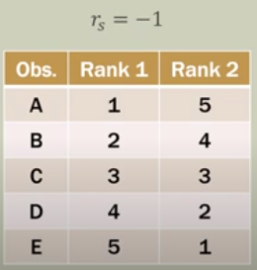
- There is an inverse correlation in the ranks, so there is a Spearman rank coefficient of -1.
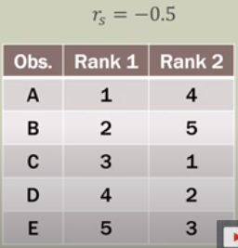
- The Spearman rank correlation would be -0.5, it's difficult to see but consider the Rank 2 ascending order 4,5 then it goes back to 1,2,3; while the Rank 1 is in ascending order all.
Dow 30 stock two-day challenge:
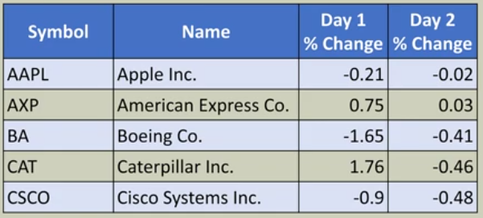
- These represent the percentage change in one day for 5 different companies' stocks.
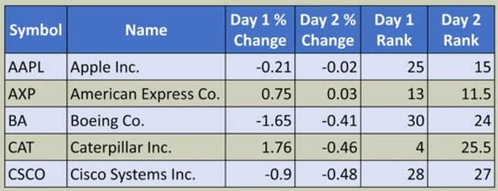
- Now look at the ranking of the companies in question, examine the change in the ranks.
- These ranks is what we will use in the spearmen correlation.
Sample statistic:
- This is the sample statistic to calculate the $r_{s}$.
$$r_{s}=1-\frac{6\sum_{t=1}^{n}{d_{i}^{2}}}{n\left(n^{2}-1\right)}$$
  - $n:$ number of observations.
  - $x_{i}$: rank of observation $i$ for the first variable in pair (see below).
  - $y_{i}$: rank of observation $i$for the second variable in pair (see below).
  - $d_{i}=x_{i}-y_{i}$
Sampling distribution:
- The spearman correlation coefficient actually has a sampling distribution.
- Mean: $μ_{r_{s}}=0$
- Standard distribution: $σ_{r_{s}}=\sqrt{\frac{1}{n-1}}$
- Approximately normally distributed if $n≥10$, some resources have it as $n≥30.$
Excel:
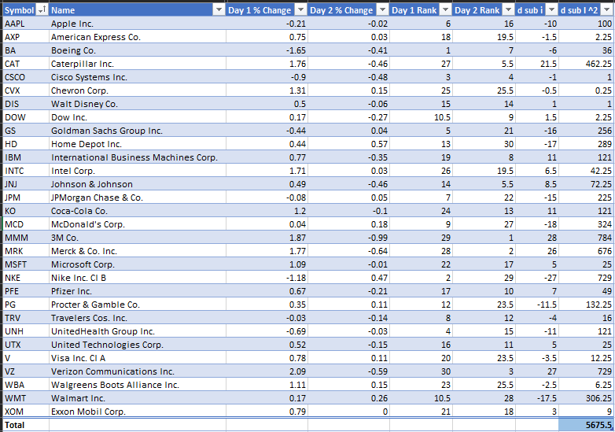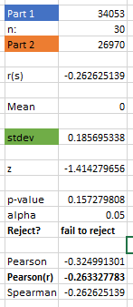
Spearman rank-correlation coefficient:
- Here the correlation coefficient is negative, this means there tents to be a negative relationship between the ranks from day one in compared to day two, so the ranks somewhat inverted from day 1 to day 2, they didn't exactly invert but it is tending that way.
- $-0.263$ means a low to moderate correlation, this does not tell us if the correlation is statistically significant, to figure that our we need to conduct the hypothesis test.
$$r_{s}=1-\frac{6\sum_{t=1}^{n}{d_{i}^{2}}}{n\left(n^{2}-1\right)}=-0.263$$
Sampling distribution:
- Mean: $μ_{r_{s}}=0$
- Standard deviation: $σ_{r_{s}}=\sqrt{\frac{1}{n-1}}=0.1857$
- Approximately normally distributed if $n≥10$ so we conducted the test.
Test statistic and p-value:
- Find the z-value: $z=\frac{r_{s}-μ_{r_{s}}}{σ_{r_{s}}}=\frac{-0.263-0}{0.186}=-1.414$
- $p-value:$=2*NORM.S.DIST(-1.414,TRUE) $0.157$
- Compare to $α$: $0.157≤0.05→$ fail to reject and there is not enough evidence to suggest there is a correlation.
- For us to reject the null, we would need a bigger z-value; another way of rejecting the null is making the sample size bigger because this would affect the standard deviation which would boost chances to reject the null and for the correlation to be approved by the hypothesis test.
  - If the sample size were to grow, that would mean the standard deviation is larger and thus the z-value grows.
  - If the $r_{s}$ were to become larger we could increase the z-value.

MOOD'S MEDIAN TEST IN EXCEL
Background:
- In the first and second videos in this playlist, we learned about the sign test for a single sample median.
- Suppose we would like to compare the medians of two or more groups?
- It is based on the sign test and the chi-square test (contingency table).
- Mood's median uses the overall median for all samples combined into one large dataset. If we have 2 samples, we merge them together and then use the median of that combined dataset that holds true for whatever samples we might have.
- Think of it as the sign test for more than one sample.
- If the medians are the same, we should expect each sample to have the same proportion of observations below and above the median of the combined samples median.
- Think of it as a nonparametric version of the One-Way ANOVA.
- The Kruskal-Wallis is "better" in that it considers the ranks of the observations not just the sign. The Kruskal-Wallis is statistically stronger.
- The Kruskal-Wallis and the Mood's median test are basically answering the same question in a different way.

General question:
- Are the independent samples from the same overall population?
- Have the independent samples been selected from different populations that have different medians?
General Hypothesis:
- $H_{0}:$ samples come from the same population.
- $H_{a}:$at least one sample comes from a different population.
- Rejecting $H_{0}$ means that there is a difference among the locations of the medians (the test does not tell us where).
- Mood's median test uses the chi-squared statistic. It is a comparison between the proportion of observations we observe relative to the overall median vs what we would expect relative to the overall median if the samples came from the same population.
Sample visuals:
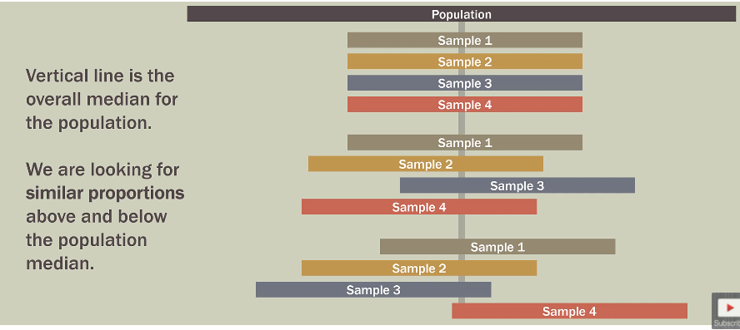
- We are checking if each of the samples have the same proportion of observations above or below the median.
Mumbai Starbucks:
- Sixty students from Mumbai, India who often study at Starbucks were asked to provide ratings for store; 15 students for each store.
- Each student was asked to review the Churchgate (C), Nariman Point (N), Taj Mahal Palace (T), and Horniman Circle (H) stores.
- The survey covered five criteria: cleanliness, service, facilities, drink quality, and food quality each on a scale of 1 to 5.
- The lowest possible score possible is 5 and the maximum is 25.
- We would like to test if the medians are the same for the stores.
Setting up the table:
- First lets check for two medians.
- Now we find the median for the combined sample:
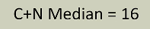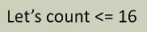
- Then we count the observations that are less than or equal to the median in this case 16.

- Now lets put this data in to a table:
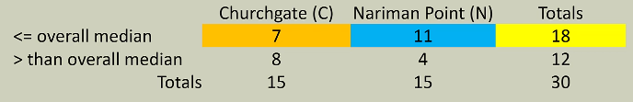
Visual of 2x2 Mood's median:
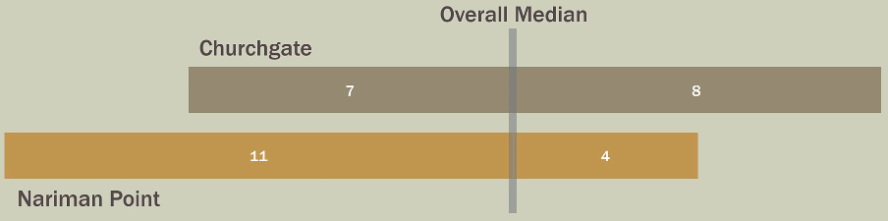
- Now use the chi-square to see if this difference is statistically speaking.
- Note: in this example, there were several (6) observations that were equal to the overall median. Five (5) of those were in Nariman Point. That is why the graphic is "lopsided" below the overall median.
Observed vs. Expected (C&N):
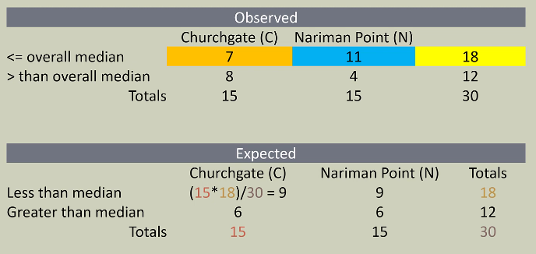
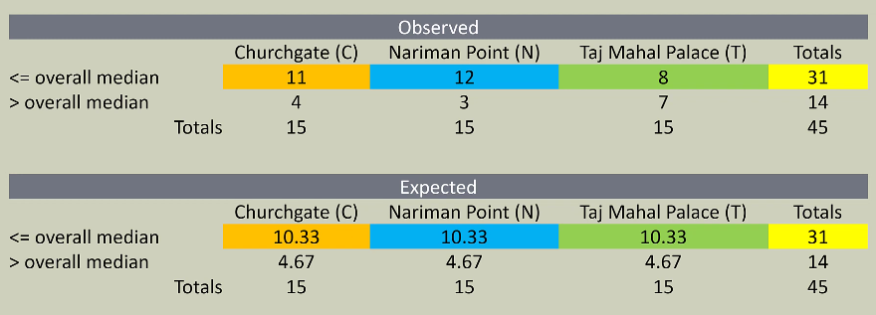
Visual of 3x2 Mood's median:
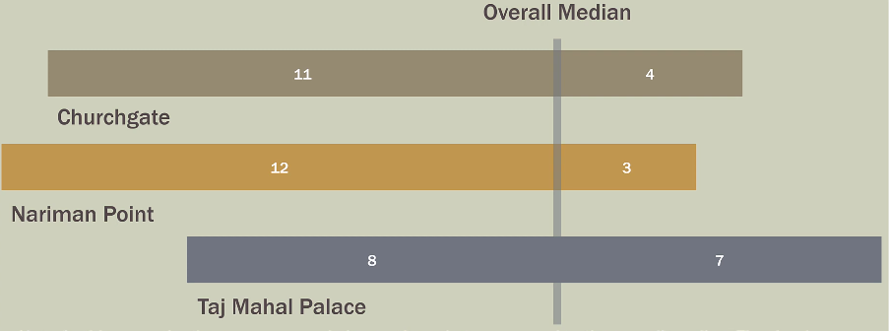
Observed vs. Expected (C,N,T,&H)

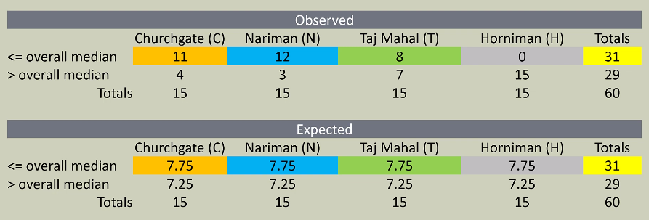

Visual of 4x2 Mood's median
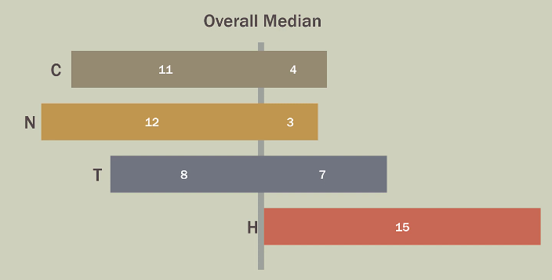
Chi-squared test statistic and p-value:
- Test statistic: $χ_{a, \left(r-1\right)\left(c-1\right)}^{2}$
  - $r:$ rows.
  - $c:$ columns.
- We reject our null hypothesis if $p-value≤α$
  - Remember the p-value is the are area in the distribution curve.
- We can also use the critical value: if $χ^{2}≥χ_{a,\left(r-1\right)\left(c-1\right)}^{2}$
  - The critical value is a location in the distribution curve.
Excel:
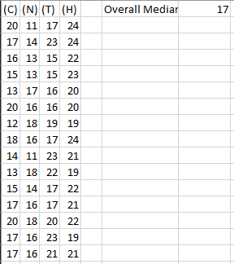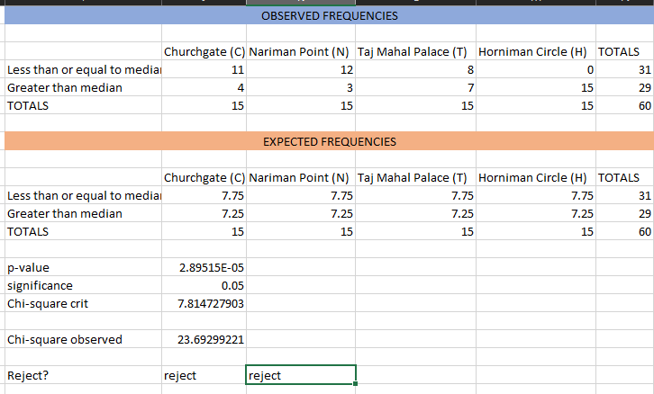
Results:
- Test statistic: $χ_{0.05, 3}^{2}$
- Rejected $H_{0}$:
  - $p-value≤0.001$
  - Critical value: $23≥7.81$
- $H_{a}$: at least one sample comes from a different population; Groups (store ratings) do not have the same median.
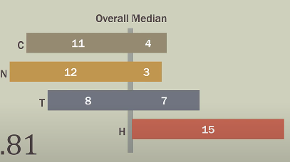
- Most likely the Horniman Circle store is the one that has the sample belonging to a different distribution.

Chi-square curve
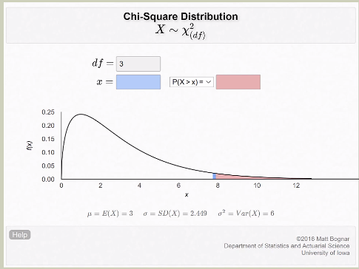
- The pink part is the significance level in this case 0.05 in terms of area., the blue is the critical value (the location of where the p-value starts).
- 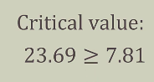 Check where is 23.69, its way up into the right.

ARISTONDO'S INSIGHTS:
Dependencies:
- What is a hypothesis of investigation?
- What is categorical data?
- Examine Aristondo's flow diagram of hypothetical testing.
Wilcoxon according to Aristondo is a more robust kind of test in comparison with the signed rank test (Paired signed test), the t-shit analogy states that if you know a friend only slightly you would aim to buy him a shirt that is bigger to increase the probability of the shirt fitting him, if you however know your friend very well you will buy the shirt more accurately because you feel confident enough to know his size, this is true not because of the continuity correction factor but rather because Wilcoxon takes into account symmetry and more data, you have more data to adjust the data, the ranked pair test does not take symmetry nor require more data.
- If you can reject the null using a ranked pair sign test, it is almost certain that you would be able to reject it in Wilcoxon, after all you could reject it with the less accurate test so a more accurate one would reassure your findings. Wilcoxon could however be able to reject a null when a signed rank paired test cannot.
- Correlation $≠$Dependence.

